سيف رضا محمدبيوميName :   
  
B.N : 374   
Group: 3   
Section: 17   
Faculty Of Engineering – Shoubra Benha University   
  
*Computer Project*

**Topic : Programing Languages**A **programming language** is a [formal language](https://en.wikipedia.org/wiki/Formal_language) comprising a set of [strings](https://en.wikipedia.org/wiki/Formal_language#Words_over_an_alphabet) that produce various kinds of [machine code output](https://en.wikipedia.org/wiki/Machine_code). Programming languages are one kind of [computer language](https://en.wikipedia.org/wiki/Computer_language), and are used in [computer programming](https://en.wikipedia.org/wiki/Computer_programming) to implement [algorithms](https://en.wikipedia.org/wiki/Algorithm).

Most programming languages consist of [instructions](https://en.wikipedia.org/wiki/Machine_instruction) for [computers](https://en.wikipedia.org/wiki/Computer). There are programmable machines that use a set of [specific instructions](https://en.wikipedia.org/wiki/Domain-specific_language), rather than [general programming languages](https://en.wikipedia.org/wiki/General-purpose_language). Since the early 1800s, programs have been used to direct the behavior of machines such as [Jacquard looms](https://en.wikipedia.org/wiki/Jacquard_loom), [music boxes](https://en.wikipedia.org/wiki/Music_box) and [player pianos](https://en.wikipedia.org/wiki/Player_piano).[[1]](https://en.wikipedia.org/wiki/Programming_language#cite_note-1) The programs for these machines (such as a player piano's scrolls) did not produce different behavior in response to different inputs or conditions.

Thousands of different programming languages have been created, and more are being created every year. Many programming languages are written in an [imperative](https://en.wikipedia.org/wiki/Imperative_programming) form (i.e., as a sequence of operations to perform) while other languages use the [declarative](https://en.wikipedia.org/wiki/Declarative_programming) form (i.e. the desired result is specified, not how to achieve it).

The description of a programming language is usually split into the two components of [syntax](https://en.wikipedia.org/wiki/Syntax_(programming_languages)) (form) and [semantics](https://en.wikipedia.org/wiki/Semantics_(computer_science)) (meaning). Some languages are defined by a specification document (for example, the [C](https://en.wikipedia.org/wiki/C_(programming_language)) programming language is specified by an [ISO](https://en.wikipedia.org/wiki/International_Organization_for_Standardization) Standard) while other languages (such as [Perl](https://en.wikipedia.org/wiki/Perl)) have a dominant [implementation](https://en.wikipedia.org/wiki/Programming_language_implementation) that is treated as a [reference](https://en.wikipedia.org/wiki/Reference_implementation). Some languages have both, with the basic language defined by a standard and extensions taken from the dominant implementation being common.

Screenshots  
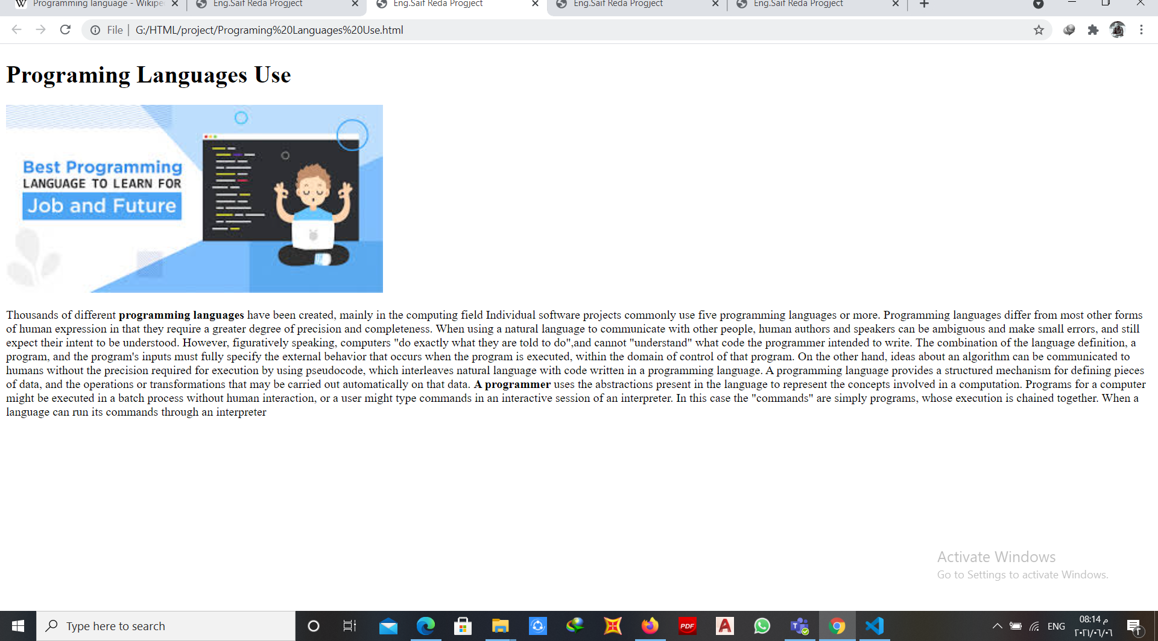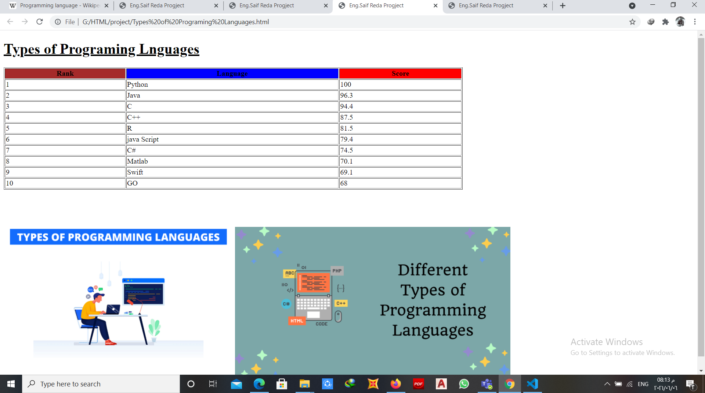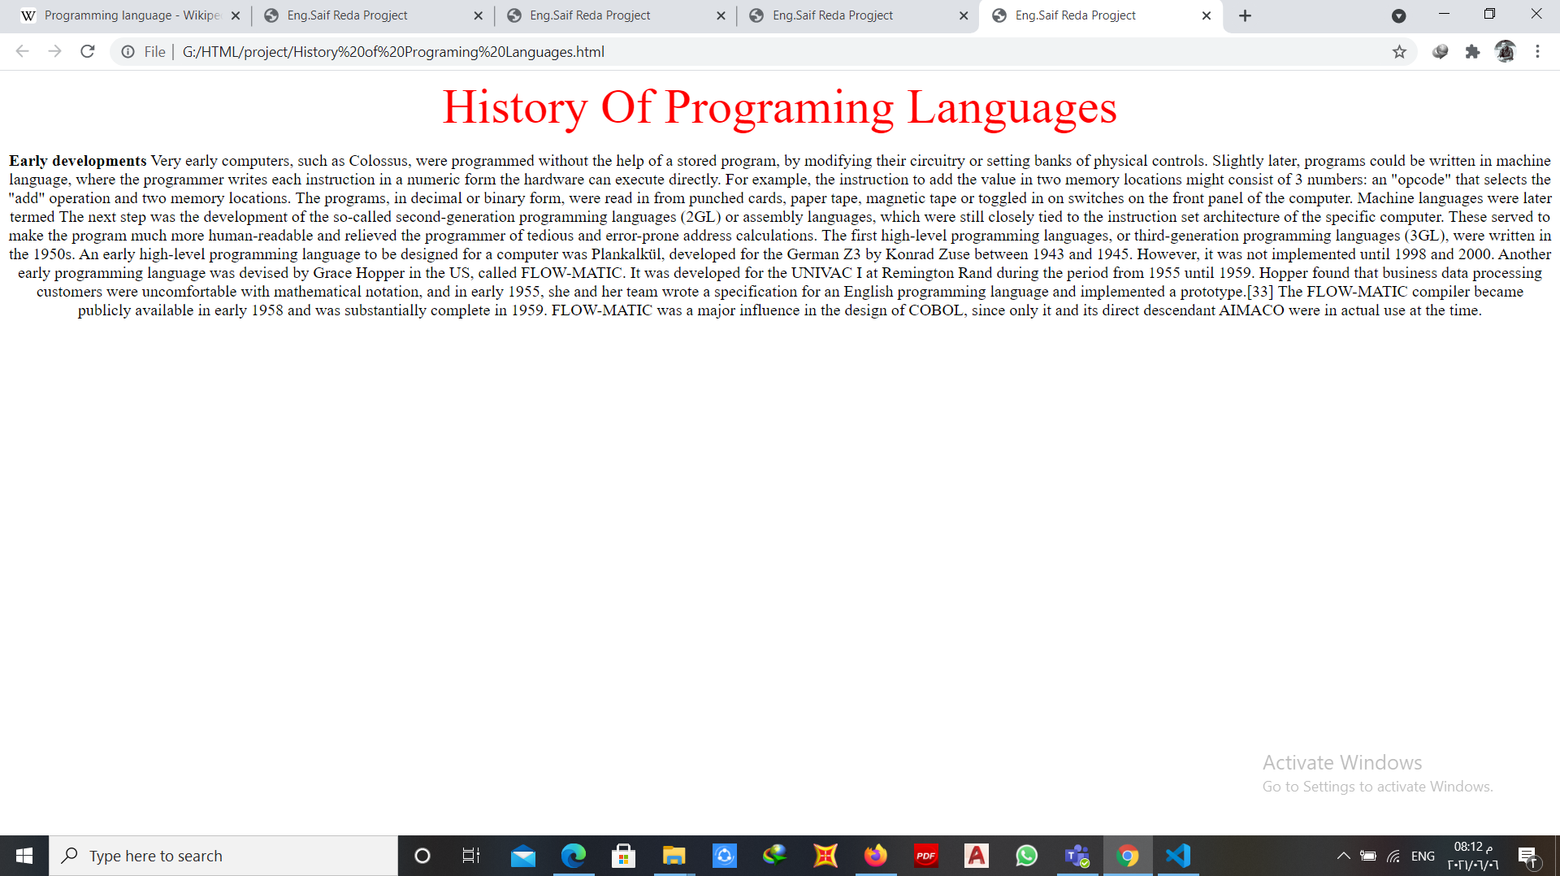

Sourcecode:  
